BLOCKCHAIN TECHNOLOGY

**ASSIGNMENT-1**

**NAME:** OLIVER RAJ. A

# 1.Go to the chrome and open remix platform

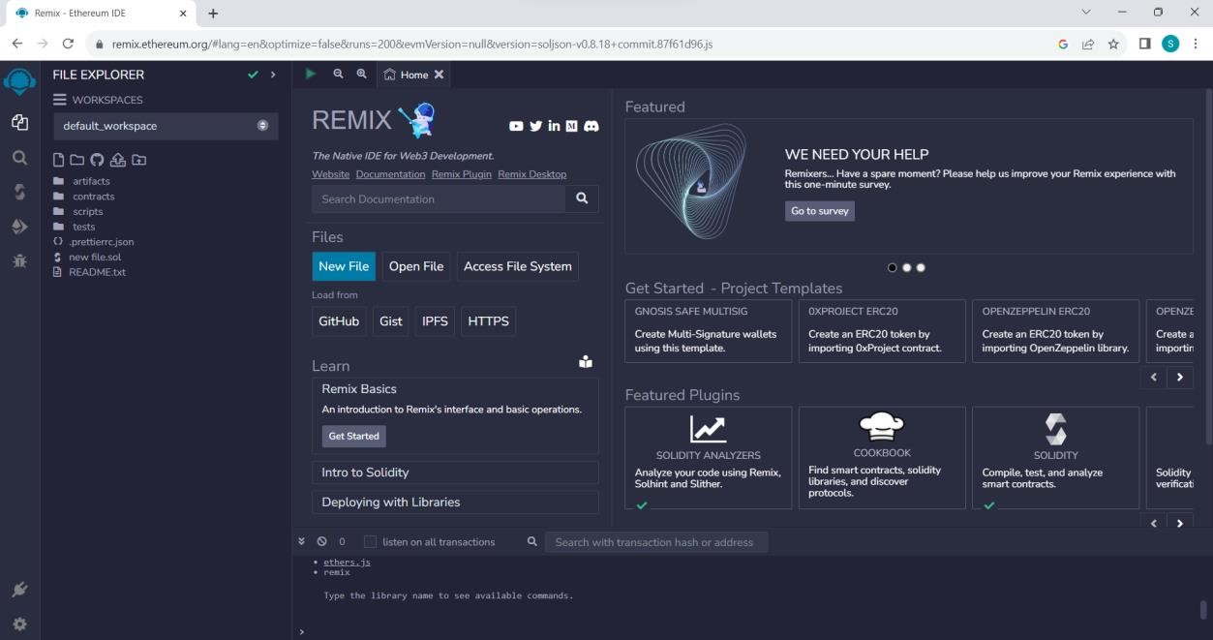

# 2.Open the remix page and create a new file

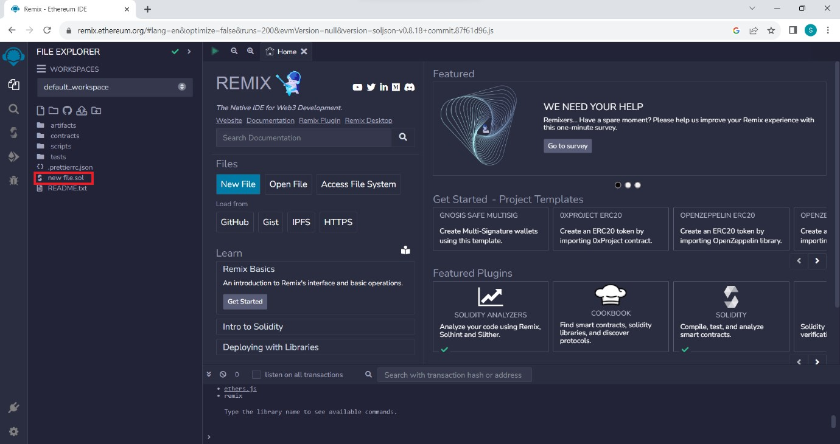

# 3.In that newly created file, create a program to return your string, "Zone name"

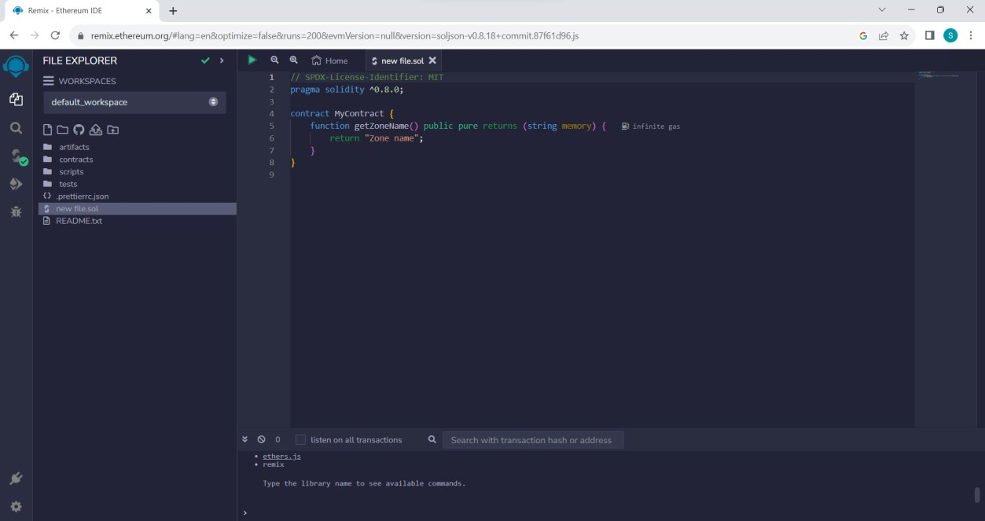

# 4.Save the program and compile it to get the ABI and Bytecode

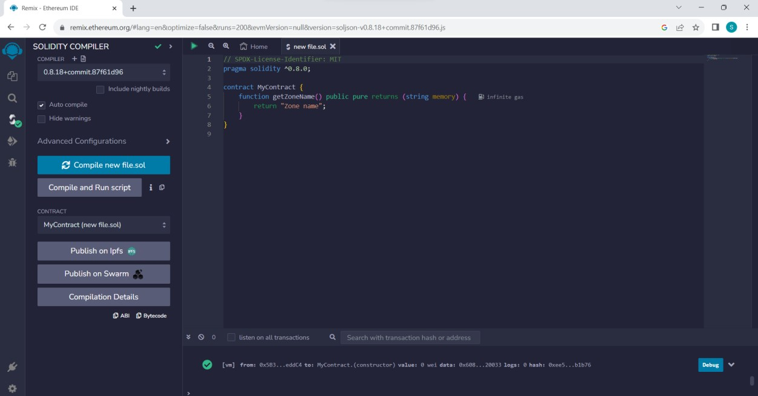

**ABI:**

[

{

"inputs": [],

"name": "getZoneName",

"outputs": [

{

"internalType": "string",

"name": "",

"type": "string"

}

],

"stateMutability": "pure",

"type": "function"

}

]

**Bytecode:**

608060405234801561001057600080fd5b50610173806100206000396000f3fe608060405234801561

001057600080fd5b506004361061002b5760003560e01c8063235ed70f14610030575b600080fd5b61

003861004e565b604051610045919061011b565b60405180910390f35b60606040518060400160405

280600981526020017f5a6f6e65206e616d6500000000000000000000000000000000000000000000 00815250905090565b600081519050919050565b600082825260208201905092915050565b60005b

838110156100c55780820151818401526020810190506100aa565b60008484015250505050565b600

0601f19601f8301169050919050565b60006100ed8261008b565b6100f78185610096565b93506101

078185602086016100a7565b610110816100d1565b840191505092915050565b6000602082019050

818103600083015261013581846100e2565b90509291505056fea26469706673582212201ebff89a09

59f4cfad2614b82b9c2b871297d389fdf2956d0d7f60f900f9637664736f6c63430008120033

# 5.Finally Deploy it to display the output

